Creating Microservices for account and loan

Account
AccountApplication.java
package com.cognizant.account;
import org.springframework.boot.SpringApplication;
import org.springframework.boot.autoconfigure.SpringBootApplication;
@SpringBootApplication
public class AccountApplication {
public static void main(String[] args) {
SpringApplication.run(AccountApplication.class, args);
}
}
AccountController.java
package com.cognizant.account.controller;
import org.springframework.web.bind.annotation.*;
@RestController
@RequestMapping("/accounts")
public class AccountController {
@GetMapping("/{number}")
public Account getAccount(@PathVariable String number) {
return new Account(number, "savings", 234343);
}
}
class Account {
private String number;
private String type;
private int balance;
// constructor, getters, setters
public Account(String number, String type, int balance) {
this.number = number;
this.type = type;
this.balance = balance;
}
public String getNumber() { return number; }
public String getType() { return type; }
public int getBalance() { return balance; }
}
OUTPUT:
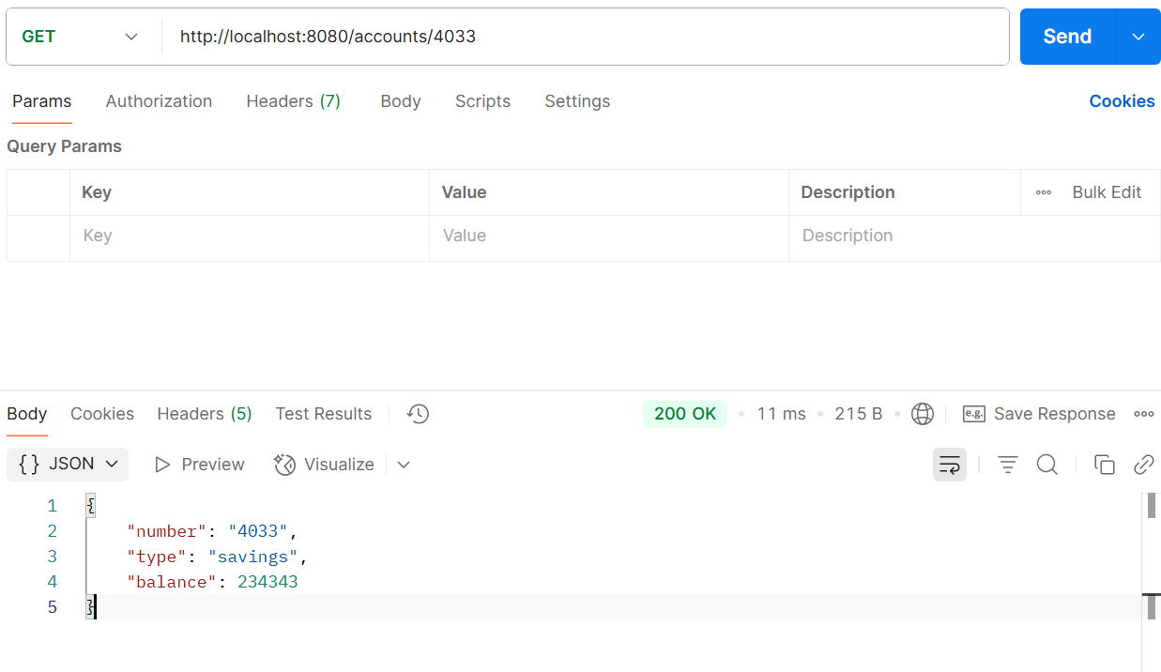
Loan
LoanApplication.java
package com.cognizant.loan;
import org.springframework.boot.SpringApplication;
import org.springframework.boot.autoconfigure.SpringBootApplication;
@SpringBootApplication
public class LoanApplication {
public static void main(String[] args) {
SpringApplication.run(LoanApplication.class, args);
}
}

LoanController.java
package com.cognizant.loan.controller;
import org.springframework.web.bind.annotation.*;
@RestController
@RequestMapping("/loans")
public class LoanController {
@GetMapping("/{number}")
public Loan getLoan(@PathVariable String number) {
return new Loan(number, "car", 400000, 3258, 18);
}
}
class Loan {
private String number;
private String type;
private int loan;
private int emi;
private int tenure;
// constructor, getters
public Loan(String number, String type, int loan, int emi, int tenure) {
this.number = number;
this.type = type;
this.loan = loan;
this.emi = emi;
this.tenure = tenure;
}
public String getNumber() { return number; }
public String getType() { return type; }
public int getLoan() { return loan; }
public int getEmi() { return emi; }
public int getTenure() { return tenure; }
}
OUTPUT:
